| Logo, company name  Description automatically generated  HIGH-LEVEL DESIGN DOCUMENT  Traffix: Dynamic Scheduling of Traffic Signals Using Machine Learning  UE21CS320A – Capstone Project Phase – 1  ***Submitted by:***  ***Kushaagra Shrivastava PES2UG21CS917***  ***Harshita Khajuria PES2UG21CS194***  ***Rishab A Kumar PES2UG21CS429***  ***Rahul G Pai PES2UG21CS414***    Under the guidance of   | **Dr. Mannar Mannan**  Associate Professor  PES University | | --- |   **January - May 2024**  **DEPARTMENT OF COMPUTER SCIENCE AND ENGINEERING**  FACULTY OF ENGINEERING  **PES UNIVERSITY**  (Established under Karnataka Act No. 16 of 2013)  Electronic City, Hosur Road, Bengaluru – 560 100, Karnataka, India |
| --- | --- |

TABLE OF CONTENTS

| 1. Introduction | 4 |
| --- | --- |
| 1. Current System | 4 |
| 1. Design Considerations | 4 |
| 3.1 Design Goals | 4 |
| 3.2 Architecture Choices | 4 |
| 3.3 Constraints, Assumptions and Dependencies | 4 |
| 1. High Level System Design | 5 |
| 1. Design Description | 5 |
| * 1. Master Class Diagram | 6 |
| 5.2 Reusability Considerations | 6 |
| 1. ER Diagram / Swimlane Diagram / State Diagram | 6 |
| 1. User Interface Diagrams | 6 |
| 1. Report Layouts | 6 |
| 1. External Interfaces | 7 |
| 1. Packaging and Deployment Diagram | 7 |
| 1. Help | 7 |
| 1. Design Details | 7 |
| 12.1 Novelty | 7 |
| 12.2 Innovativeness | 7 |
| 12.3 Interoperability | 7 |
| 12.4 Performance | 7 |
| 12.5 Security | 7 |
| 12.6 Reliability | 7 |
| 12.7 Maintainability | 7 |
| 12.8 Portability | 7 |
| 12.9 Legacy to Modernization | 7 |
| 12.10 Reusability | 7 |
| 12.11 Application Compatibility | 7 |
| 12.12 Resource Utilization | 7 |
| Appendix A: Definitions, Acronyms and Abbreviations | 8 |
| Appendix B: References | 8 |
| Appendix C: Record of Change History | 8 |
| Appendix D: Traceability Matrix | 8 |

# Introduction The project aims to solve the problem of traffic congestion at signals by dynamically scheduling signals using machine learning and real time data processing. This enhances traffic efficiency, reduce congestion, and improve overall transportation system performance.

# Current System

Currently, on our roads, traffic signals operate in 1 out of 2 ways. Either they are pre assigned a routine where a given signal, or pair of them go green at once, whilst the rest stay red. Or they are operated manually. Additionally, methods to calculate congestion at a signal are all classification based and use simple neural networks

1. **Design Considerations** 
   1. **Design Goals**

**Goals:**

* Reduced Traffic Congestion: This is the primary objective. The system should optimize signal timings to minimize wait times and maximize traffic flow efficiency.
* Adaptability: The system should adjust signal timings dynamically based on real-time traffic conditions.
* Reduced Emissions: Smoother traffic flow can lead to less idling and fewer emissions from vehicles.
* Increased Efficiency: The system should be efficient in terms of resource utilization (computational power, energy consumption), maintenance, and cost.

**Guidelines:**

* Compliance with Traffic Engineering Standards: The system design should adhere to established traffic engineering standards and regulations.
* Scalability: The system should be scalable to accommodate various intersection sizes and traffic volumes.
* Integration with Existing Infrastructure: The system should be designed for potential integration with existing traffic signal controllers and data collection systems.

**Design Principles**:

* Data-driven Decision Making: The system should leverage real-time traffic data and historical patterns to make informed decisions about signal timings.
* Machine Learning and AI: Advanced techniques like Q-learning or rule-based systems with machine learning can be used for dynamic signal adjustments.

* 1. **Architecture Choices**

Compared to existing fixed-time signal systems, the proposed system offers several advantages:

* Reduced Congestion: Dynamic adjustments based on real-time data can significantly improve traffic flow and reduce wait times.
* Environmental Benefits: Smoother traffic flow can lead to lower emissions and a cleaner environment.
* Long-term Cost Savings: Efficiency gains through reduced congestion and potentially lower maintenance needs can lead to cost savings over time.

# Constraints, Assumptions and Dependencies

* Availability: The system should be highly available with minimal downtime to ensure continuous traffic signal control. Redundancy and backup mechanisms can be implemented for fault tolerance.
* Privacy: The system should collect and store traffic data anonymously, respecting user privacy. Data anonymization techniques can be employed.
* Speed: The system should be responsive and provide real-time data updates for effective decision-making. Efficient data processing and communication protocols are essential.
* Assumes no accidents and safe and legal driving.

# **High Level System Design**

# 

1. **Swimlane Diagram**

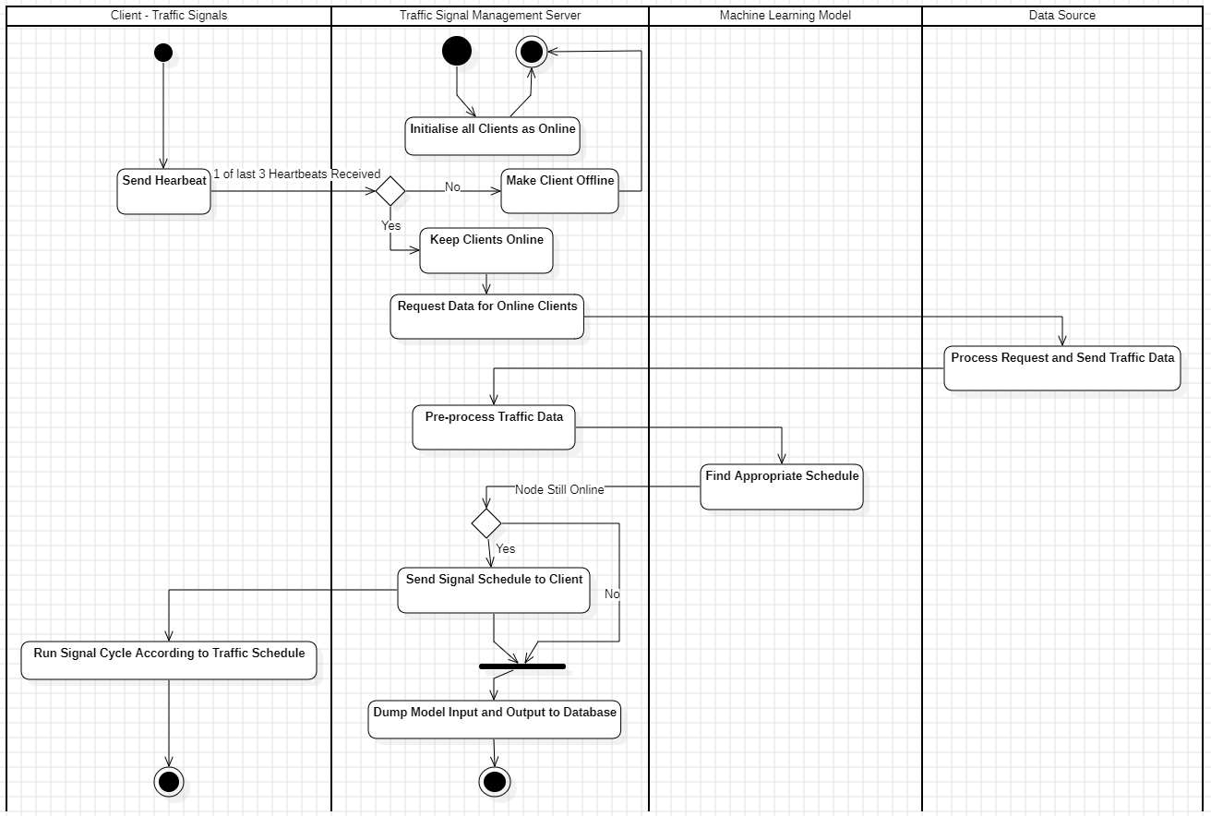

1. **State Diagrams**
   1. **Server**

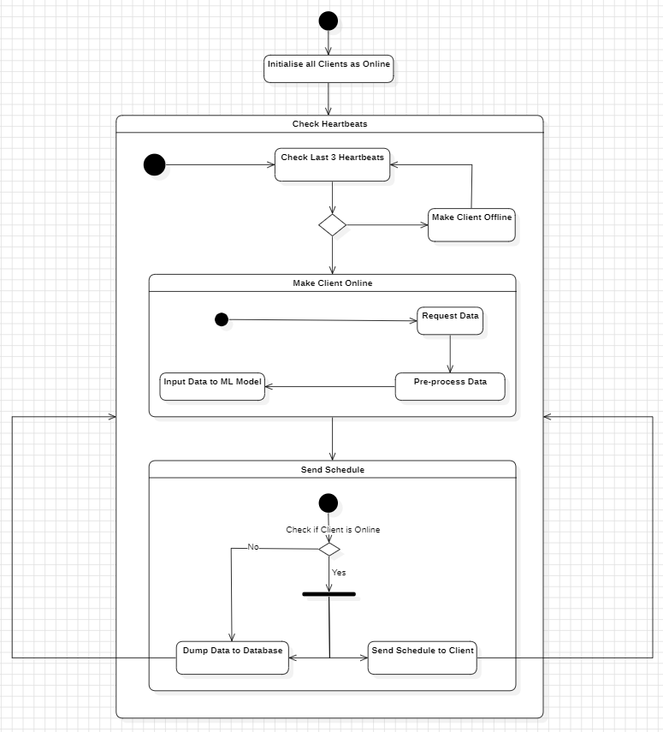

* 1. **Client**

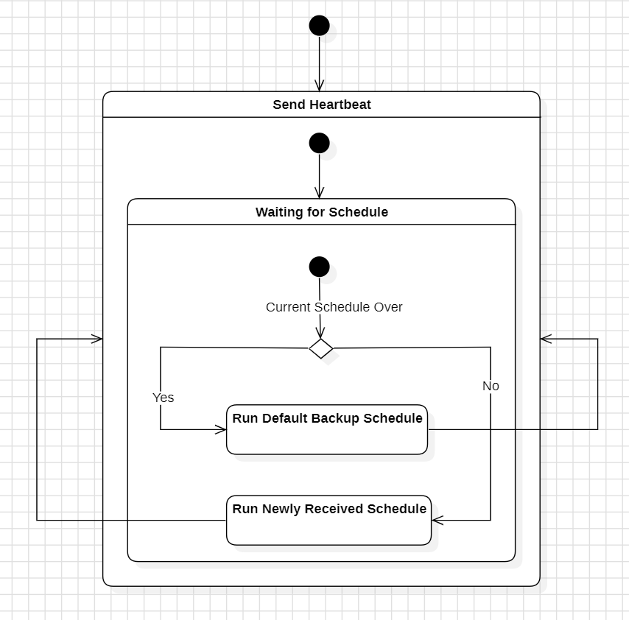

1. **Sequence Diagram**

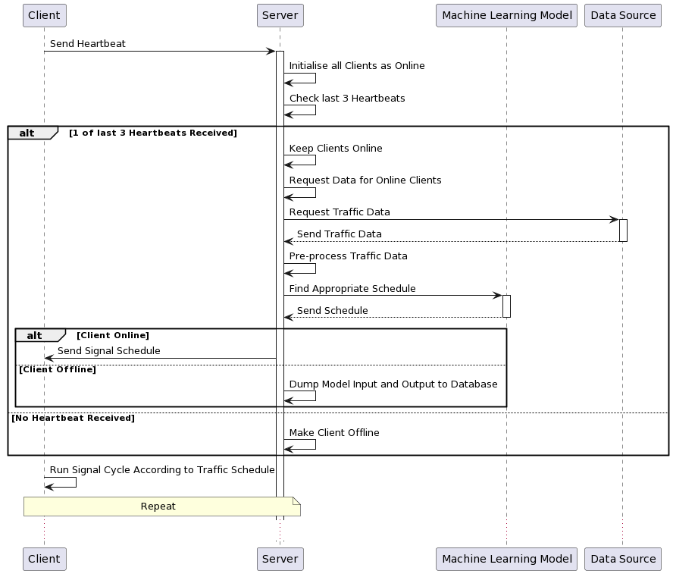

1. **Design Details**
   1. **Novelty**

* Traffic signal optimization by leveraging real-time traffic data from Google Maps
* Applying machine learning algorithms to generate adaptive signal schedules.
  1. **Innovativeness**
* Dynamic adaptation to changing traffic conditions, where signal timings are continuously adjusted based on real-time data analysis
  1. **Interoperability**
* Seamlessly integrate with existing traffic infrastructure and communication protocols
  1. **Performance**
* Capable of real time data processing
* Reliable signal time output
  1. **Security**
* Should be invulnerable to attacks trying to feed wrong data to models to mess up traffic signal timings
* Dataset should be from accurate source
  1. **Reliability**
* By introducing redundancy techniques such as increasing the number of servers and databases
  1. **Portability**
* Platform-independent, allowing for deployment across different hardware environments and operating systems
  1. **Legacy to modernization**
* Bridge between legacy traffic management systems and modern, data-driven approaches, facilitating the transition to more adaptive and efficient traffic control methods.
  1. **Reusability**
* Reusable components include machine learning models for traffic prediction and optimization, API interfaces for data integration, and modular software architecture for scalability and extensibility.
  1. **Application compatibility**
* Compatible with common traffic management applications, including traffic signal controllers, traffic simulation software (e.g., SUMO)
  1. **Resource utilization, Etc.,**
* Optimizes resource utilization through efficient algorithms for real-time data processing, scalable cloud infrastructure for computational tasks, and bandwidth management for data transmission.

# Appendix A: Definitions, Acronyms and Abbreviations

* GPS - Global Positioning System.
* IoT - Internet of Things.
* CO2 - Carbon dioxide.
* ML - Machine Learning.
* CNN - Convolutional Neural Network.
* ReLU - Rectified Linear Unit.
* HMM - Hidden Markov Model.
* UDP - User Datagram Protocol.
* TCP - Transmission Control Protocol.
* GUI - Graphical User Interface.
* IEEE - Institute of Electrical and Electronics Engineers.

# Appendix B: References

* <https://ieeexplore.ieee.org/document/10100954>
* <https://ieeexplore.ieee.org/document/10201549>
* <https://www.researchgate.net/publication/340458873_Image_Processing_and_IoT_Based_Dynamic_Traffic_Management_System>
* <https://ieeexplore.ieee.org/document/9065034>
* <https://ieeexplore.ieee.org/document/8483054>
* [Reinforcement Learning (keras.io)](https://keras.io/examples/rl/)
* [RNN — PyTorch 2.2 documentation](https://pytorch.org/docs/stable/generated/torch.nn.RNN.html)
* [pyqlearning · PyPI](https://pypi.org/project/pyqlearning/)
* [SUMO Documentation (dlr.de)](https://sumo.dlr.de/docs/index.html)

# Appendix C: Record of Change History

[This section describes the details of changes that have resulted in the current High-Level Design document.]

| **#** | **Date** | **Document Version No.** | **Change Description** | **Reason for Change** |
| --- | --- | --- | --- | --- |
|  |  |  |  |  |
|  |  |  |  |  |
|  |  |  |  |  |

# Appendix D: Traceability Matrix

[Demonstrate the forward and backward traceability of the system to the functional and non-functional requirements documented in the Requirements Document.]

| **Project Requirement Specification Reference Section No. and Name.** | **DESIGN / HLD Reference Section No. and Name.** |
| --- | --- |
|  |  |
|  |  |
|  |  |